President - Mrs G M Duckworth
Trustees – Mr N Clay, Mr J Cusack, Mr R Inchley, Mr R Seldon, Mr P Mackrell
Hon Treasurer  Mr R Seldon  Blair Drummond  Heath Park Road  Leighton Buzzard  LU7 3BB  07805 805432 | Chairman  Mr J Lowe  362 Bideford Green  Linslade  LU7 2TX  07969261972 | Secretary  Mr M Furness  30 Mentmore Road  Linslade  LU7 2NZ  07944051136

Minutes of Annual General Meeting

Canal Street Cafe, Leighton Rd, Leighton Buzzard LU71LA, on the Wednesday 28th February 2024 at 8:30pm

- Apologies

Chris George, James Bell, Matt Styrka, Bob Dickinson, Rob Elmore, Sarah Keane, Paul Griffiths, David Adams, Neil Green, Ben Corfield, Amy Inchley, Cristian de Sa, Kathryn Shepardson, Stuart Dimmock, Warren Rose, Sara Lowe, Rachael Fawcett, Valentina Ferrari.

- Chairman’s report

Membership
Year | Total | Junior | Senior
2021/22 | 211 | 98 | 113
2022/23 | 206 | 94*TBC | 112
2023/24 | 158 | 57 | 101

- Junior membership was impacted by the suspension of that section
- Senior membership remains reasonably stable and above 100 members.
- Aim is to maintain a membership between 90 minimum and 150 senior members.
Finances and membership fees
As we will be reported the club finances are in a healthy position and as ever we’ll be looking at several ways to ensure any surplus is reinvested back in the club. Significant investment this year will be needed on coaching for juniors and run leading for seniors.
Subject to further discussion at the committee we are highly unlikely to propose any increase in membership fees for next year. Membership fees will likely be frozen once again, and the inevitable EA membership fee increase absorbed once again.
I’d like to thank Pete Mackrell and our Treasurer Roger Seldon for putting the account together. I must highlight Roger in particular who has had a hellish time with Barclays this past 6 months or more. Resulting in our account being closed and us unable to make payments, through no fault of our own for several months. He spent many a long hour on the phone and even covered some member expenses himself while it was resolved, really going above and beyond.

Training and coaching
We have successfully added new members to the Tuesday and Wednesday run leaders group and laid down a clear structure on how we want these evenings to run. This has taken account of member feedback to ensure they remain as accessible as they can be for our members. Thursday nights continue to run smoothly and there a regular group who take part in speed training no matter the weather.
We have also begun monthly, long social runs on a Sunday.
We’re always looking for more people to help on any of our club nights.
Facilities, equipment and kit
- A health stock level is maintained by our Kit Manager (Will Eastman)
- In 2024 we will need to look at how we maintain the facilities at Vandyke in the absence of the junior training up there.
Leighton 10 (L10)
The Leighton 10 was a great success this year. The planning and organisation went off smoothly, as did the day itself. We saw an increase in entries this year and the event made £1362.14 back to club.
Our thanks go to Ian Grimshaw as Race Director and his hard-working Leighton10 Committee for putting on a wonderful event. Hopefully we can build on that in 2024.
Junior section
The big news in the junior section was the stepping down our long-standing team of Warren Rose, David Killick and Nick Clay. The club once again extends our thanks to their many of years of dedicated service to our junior section.
Unfortunately, this did impact heavily on junior training and events. Although we completed a full track and field season, full athletics training ended on 31 August. Warren kindly has kept an endurance run group going which has enabled a small / hardy group to continue training through the XC season. Warren will step down in August.
The club is committed to reestablishing our junior section. This is a core part of what we do and set out in our charitable goals. However, this will be a slow and gradual process, as it takes time to train coaches. So, the plan is to build back gradually. I plan to take over the endurance group that runs on Thursday from April. Training will be offered to ages groups 12+ and initially training numbers will be limited. We will then look to recruit and train more people over the next few years. The focus may initially be running but we do hope we can get back to providing field event training over time.
This will be an immense challenge but by going back to basics we can continue to offer a training and opportunities to compete to the young people of the town.
Events and Racing
Once again, our Club Captains developed a fantastic calendar of events for the past 12 months across our various championship – road, off road, cross country and track and field.
In 2023/24 we will continue to actively encourage participation by promoting our various championships particularly to new members who may be less aware of what’s involved.
Cross Country
The club maintained a respectable mid-table position in the Chiltern XC League this year. We were 8th overall, and in the men’s section, and 9th overall for the ladies. This is down a couple of places on last year but still a solid set of results. It was a challenging year with a host of injuries and general unavailability meaning we rarely had all our strongest runners available at each event. It remains true though that when we do then the club is capable of challenging further up the table, possibly even pushing for a top 3 or 4 finish.

Road
The road series saw a disappointing drop off in attendance after a good year in 2023. Participation was lower for both men and women but in the latter case for a couple of the events we struggled to even to get 3 people attend.
The committee will discuss this at future meetings to see how greater participation can be encouraged.
Off Road / Trail
The off-road series is home to some great and challenging events. Participation has been good this year with the relays being particularly well attended again. It was pleasing once again to pick up trophies at both Greensands and the MK relay.
Track and field
From a senior perspective this remains a challenge for participation. The juniors completed a full season before the coaches stepped down. The committee will review plans for track and field in the coming months.

Draft committee priorities for the next year
In no particular order:
- Ensure the Leighton 10 continues to grow and be successful event for the local area.
- Invest in coaching courses for those that are keen to develop their skills and support the club so we can enhance the quality of what we offer (both for juniors and seniors)
- Look at our event participation, particular for road events, and try to understand where it can be improved or what we can do differently.
- Look to develop the social aspects of the club based on feedback from our membership.
- Review our internal communications to ensure everyone is getting the information they need about what’s happening with the club.
I’d finish by saying that anything we as club want to do or achieve is reliant on people coming forward to help. So, I extend my sincere gratitude to anyone and everyone who has helped in the last 12 months. I would add though that both the club’s and committee’s resources are finite, so if we are to develop new areas then we need new people to come forward and help. Not just with issues or ideas but also some willingness to help implement them.

James Lowe
Club Chairman (General Committee)

- Presentation of accounts for the year ended 31st December 2023

Roger Seldon presented the following summary of accounts:

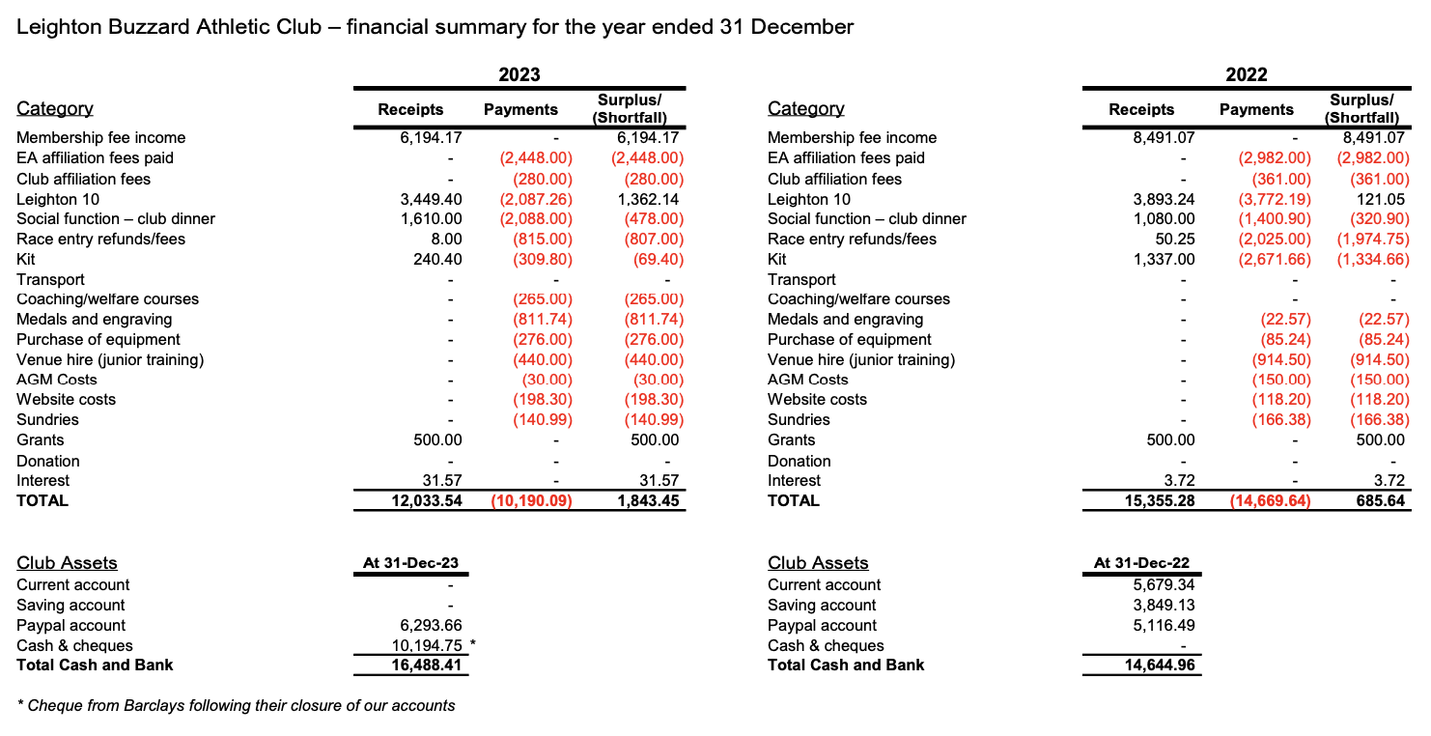

Roger described the difficulties the Club had experienced with banking following the change to charitable status. This had impacted across the whole charitable sector. Members discussed the pros and cons of this move.

Roger was thanked for his determination and resilience across the year by all present

- Election of Trustees

Nick Clay stepped down and was re-elected

- Election of Officers

- Club President

Gail Duckworth has stepped down after as President. The Club’s thanks and appreciation to Gail was noted. The Committee would discuss the role of President and who would be best placed to take on the role in the future at the next meeting.

- Social Secretary

Members were invited to nominate themselves as the lead for coordinating social events. No one came forward and it was agreed that in lieu of a formal lead that all were welcome to come up with ideas for social occasions on an informal basis.

- Committee Positions

Valentina Ferrari was elected as Vice Captain (proposed by Dan Webb, seconded by Tim Inchley).
Ed Toosey was elected as a Committee member (proposed by Ian Grimshaw, seconded by Ruth Eastman).

Position | Committee 2023-24 | Committee 2024-25
Chairperson: | James Lowe | James Lowe
Secretary: | Michael Furness | Michael Furness
Treasurer: | Roger Seldon | Roger Seldon
Captain: | Sam Dear | Sam Dear
Vice-Captain: | Ruth Mitchell | Valentina Ferrari
Publicity Officer: | Sara Lowe | Sara Lowe
Committee Members: | Alison Bell  Jo Dear | Jo Dear  Ed Toosey

Non-Committee Roles:

Membership Secretary: | Ben Corfield
Leighton 10 Race Director: | Ian Grimshaw
Leighton 10 Subcommittee: | Alison Bell, Ian Grimshaw, Greg Pearce, Orla Feily & Ruth Eastman
Cross Country Fixture lead: | Richard Inchley
Thursday Training Leaders: | Mike Furness & Charlie Mead
Run Leaders: | James Lowe, Ian Grimshaw, Alison Bell, Amy Farnfield, Dan Webb, Liz Peters, Ed Toosey, Nick Clay
Annual Dinner Coordinators: | Ian Grimshaw & Jeni Read
Website Editors: | Andy Inchley, Sam Dear, Mike Furness
Welfare Officers: | Jo Dear, Warren Rose, Pete Mackrell, Jeni Read
Publicity / newsletters: | Sara Lowe, Rachel Fawcett, Liz Peters

Tim Inchley noted that with James Bell moving there was now a gap in organising the Ridgeway Relay. Also, that other relays such as the round Norfolk Relay were good options for participation, although would require a good deal of organising. The Chair agreed and invited members to put themselves forward as organisers if they wished.

- Any Other Business

None raised.

